Ideation Phase
Brainstorm & Idea Prioritization Template

Date | 28 August 2026
Project Name | Employee Raise Issue
Maximum Marks | 4 Marks

Brainstorm & Idea Prioritization Template:
Brainstorming for the Employee Service Request Management System in ServiceNow involves identifying ways to simplify the process of submitting and managing employee service requests. Employees may require assistance related to IT services, HR support, workplace facilities, access permissions, or administrative services. During brainstorming, different ideas are proposed, including a categorized request form, automatic assignment to responsible teams, request-priority settings, status tracking, and automated notifications. These ideas are evaluated according to their usefulness, ease of implementation, and ability to reduce delays in employee service delivery.
Step-1: Team Gathering, Collaboration and Select the Problem Statement
The team identifies the difficulties employees experience while requesting workplace support. Employees may not know which department should handle their request, may have limited visibility into request progress, and may not receive updates at the right time.
Problem Statement:
Employees need a centralized system where they can submit workplace service requests, select the appropriate request type, monitor progress, communicate with the support team, and receive timely updates until the request is completed.
Project:
Employee Raise Issue Management System using ServiceNow
The team analyzes employee requirements and identifies important areas such as request submission, department assignment, priority handling, progress monitoring, notifications, and service improvement.

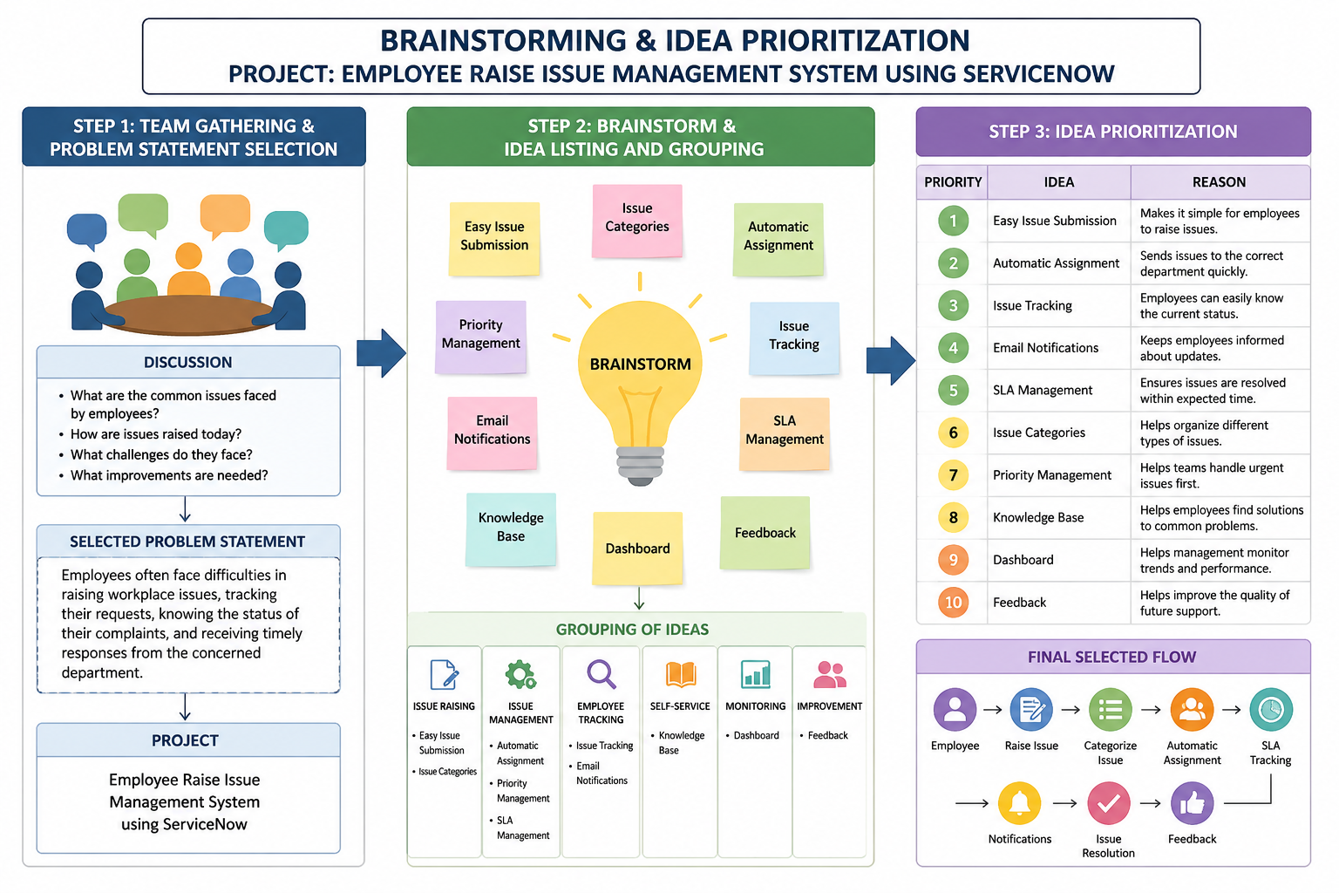``

Step-2: Brainstorm, Idea Listing and Grouping
During the brainstorming session, the team discusses different ideas for making employee support requests easier to manage.
Idea | Description
Simple Request Form | Provide an easy-to-use form for employees to submit service requests.
Request Type Selection | Allow employees to select the type of support they require.
Department Routing | Route requests to the relevant support team based on the request type.
Urgency Identification | Capture the urgency of a request to help determine its priority.
Request Status | Allow employees to view whether their request is new, in progress, or completed.
Automatic Alerts | Notify employees when their request is created or its status changes.
Escalation Process | Escalate requests when they remain unresolved beyond the expected time.
Self-Service Support | Provide useful information for frequently faced employee problems.
Admin Dashboard | Help administrators monitor request volume and resolution progress.
Service Rating | Allow employees to provide a rating after their request is completed.

Service Rating Allow employees to provide a rating after their request is completed.
Grouping of Ideas:
- Request Submission: Simple Request Form, Request Type Selection
- Request Processing: Department Urgency Identification, Escalation ProcessRouting
- Request Monitoring: Request Status, Automatic Alerts
- Self-Service: Self-Service Support
- Administration: Admin Dashboard
- Service Improvement: Service Rating

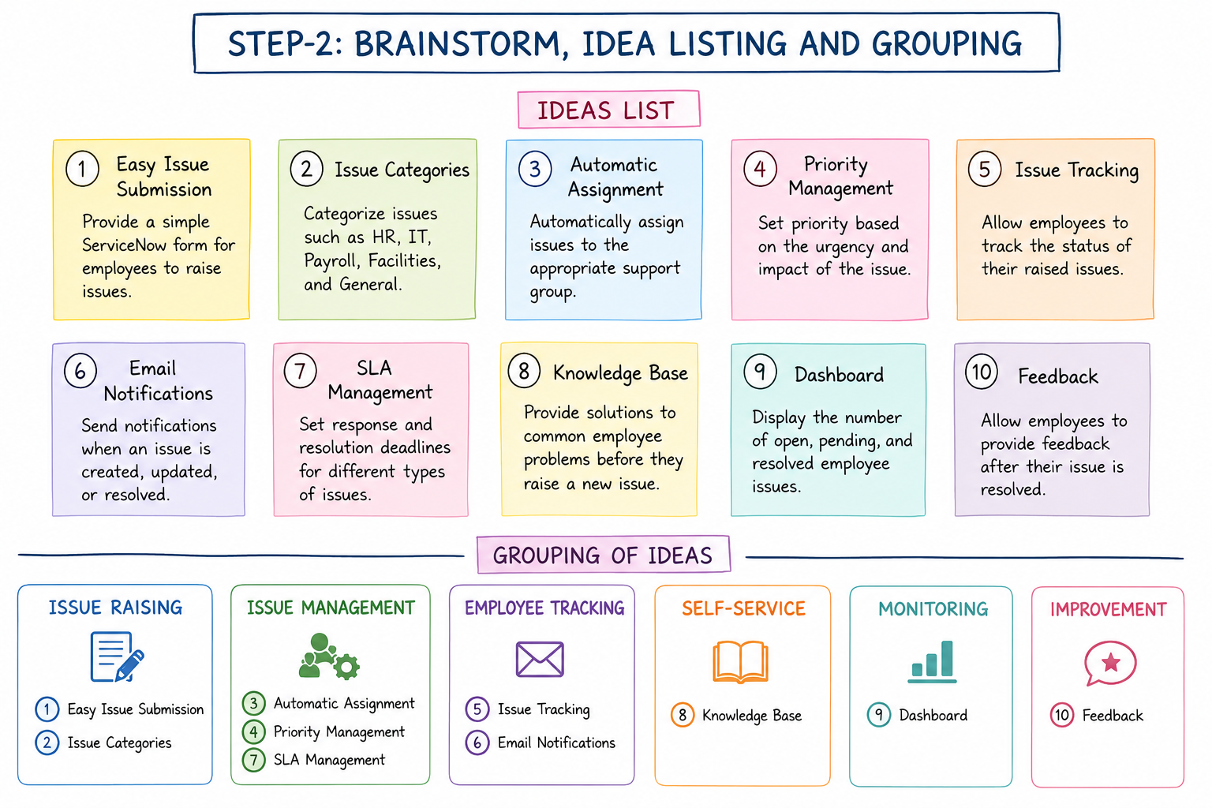

Step-3: Idea Prioritization
The identified ideas are prioritized by considering their usefulness to employees, feasibility of implementation, and contribution to efficient request handling.
Priority | Idea | Reason
High | Simple Request Form | Makes submitting requests easier and faster.
High | Department Routing | Helps send requests to the appropriate support team.
High | Request Status | Provides visibility into the progress of requests.
High | Automatic Alerts | Keeps employees informed about important changes.
High | Escalation Process | Helps prevent requests from remaining unresolved for long periods.
Medium | Request Type Selection | Helps organize requests according to their purpose.
Medium | Urgency Identification | Helps support teams understand which requests need quicker attention.
Medium | Self-Service Support | Enables employees to find information for common problems.
Medium | Admin Dashboard | Helps administrators monitor request activity and progress.
Low/Medium | Service Rating | Provides feedback that can be used to improve support services



